Correctional Treatment Board

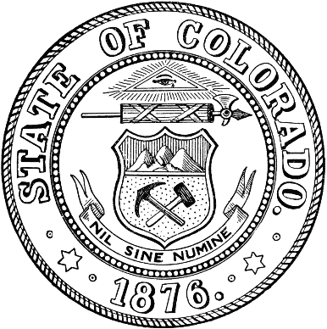
September 15, 2026
Microsoft Teams
1:00pm -3:00pm

- Administration
  - Approval of August Meeting Minutes – Jaime/Heather

- FY2027 Monthly Budget Update– Liz Hills

- FY2028 Funding Plan Draft – VOTE

- Agency Fund Reallocation – Update Liz and Katy

- Chair Position – Vote

- Updates from Board Members or Visitors

- October Meeting Agenda Requests

Next Meetings:
Tuesday, October 20, 2026: 1pm-3pm
Tuesday, November 17, 2026: 1pm – 3pm
Tuesday, December 15, 2026: 1pm-3pm

Meeting dates, minutes, and other documents are posted on the Correctional Treatment Board’s website: https://www.coloradojudicial.gov/probation/correctional-treatment-board?topic=155&wrapped=true

Board Co-Chair
Jaime FitzSimons, Sheriff
Summit County Sheriff’s Office

Board Co-Chair
Heather Salazar, Associate Director
Division of Adult Parole,
Department of Corrections

Board Members
James Karbach, State Public Defender
State Public Defender’s Office

Matthew Lunn, Director
Division of Criminal Justice
Department of Public Safety

Anjali Nandi, Director
Division of Probation Services
State Court Administrator’s Office

Danielle Culp, Director
Criminal Justice Services
Division of Community Behavioral Health
Behavioral Health Administration

Jessica Waggoner, District Attorney
Colorado District Attorney’s Council

Board Coordinator
Katy Post
State Court Administrator’s Office
Division of Probation Services

