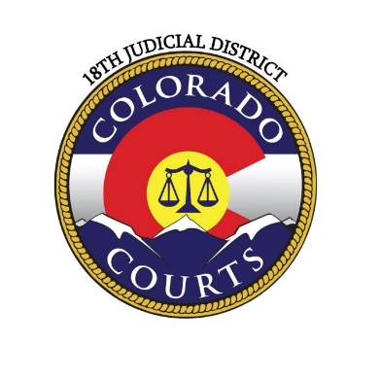
Eighteenth Judicial District
Arapahoe County

Emergency Election Matters
November 4, 2025

If you have emergency election matters that need to be heard after hours, please contact the Clerk of Court for Arapahoe County at the following number:

Arapahoe- 303-645-6789

They will then contact the Election Night Duty Judge to determine the appropriate course of action.

