Correctional Treatment Board

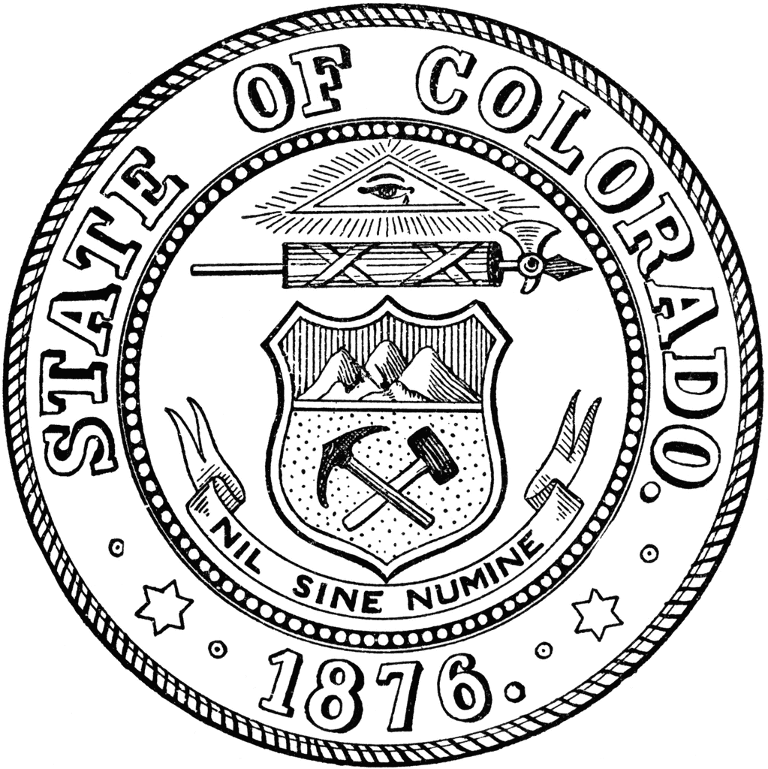
May 20, 2025

Members in Attendance: Heather Salazar, Anjali Nandi, Danielle Culp, Jaime FitzSimons, Jessica Waggoner, Matt Lunn, and James Karbach.

Guests in Attendance: Kelly Sawka, Morgan Mote, Community Member, and Carla Hanson, CTB Coordinator role (Frances Blair absent)

- Approved minutes for the April 2025 Meeting

- Kelly Sawka reviewed the CTB monthly Budget and discussed SB25-317 with respect to interest. This bill will affect about $800,000 in the CTB budget for future years.

- Local Board Projects were discussed. Applications are being submitted through June 1, 2025, for FY27. Training on Amplifund will be provided at the next meeting.

- A reminder that FY2027 Annual Agency Requests are due August 1st, 2025

- A request was made to try TEAMS as a meeting platform for the next meeting.

Next Meetings:
Tuesday, June 17, 2025: 1pm-3pm
Tuesday, July 15, 2025: 8am-5pm (in person)
Tuesday, August 19, 2025: 1pm – 3pm

Meeting dates, minutes, and other documents are posted on the Correctional Treatment Board’s website: https://www.coloradojudicial.gov/probation/correctional-treatment-board?topic=155&wrapped=true

Board Co-Chair
Jaime FitzSimons, Sheriff
Summit County Sheriff’s Office

Board Co-Chair
Heather Salazar, Associate Director
Division of Adult Parole,
Department of Corrections

Board Members
James Karbach, State Public Defender
State Public Defender’s Office

Matthew Lunn, Director
Division of Criminal Justice
Department of Public Safety

Anjali Nandi, Director
Division of Probation Services
State Court Administrator’s Office

Danielle Culp, Director
Criminal Justice Services
Division of Community Behavioral Health
Behavioral Health Administration

Jessica Waggoner, District Attorney
Colorado District Attorney’s Council

________

Board Coordinator
Frances Blair
State Court Administrator’s Office
Division of Probation Services

