Correctional Treatment Board

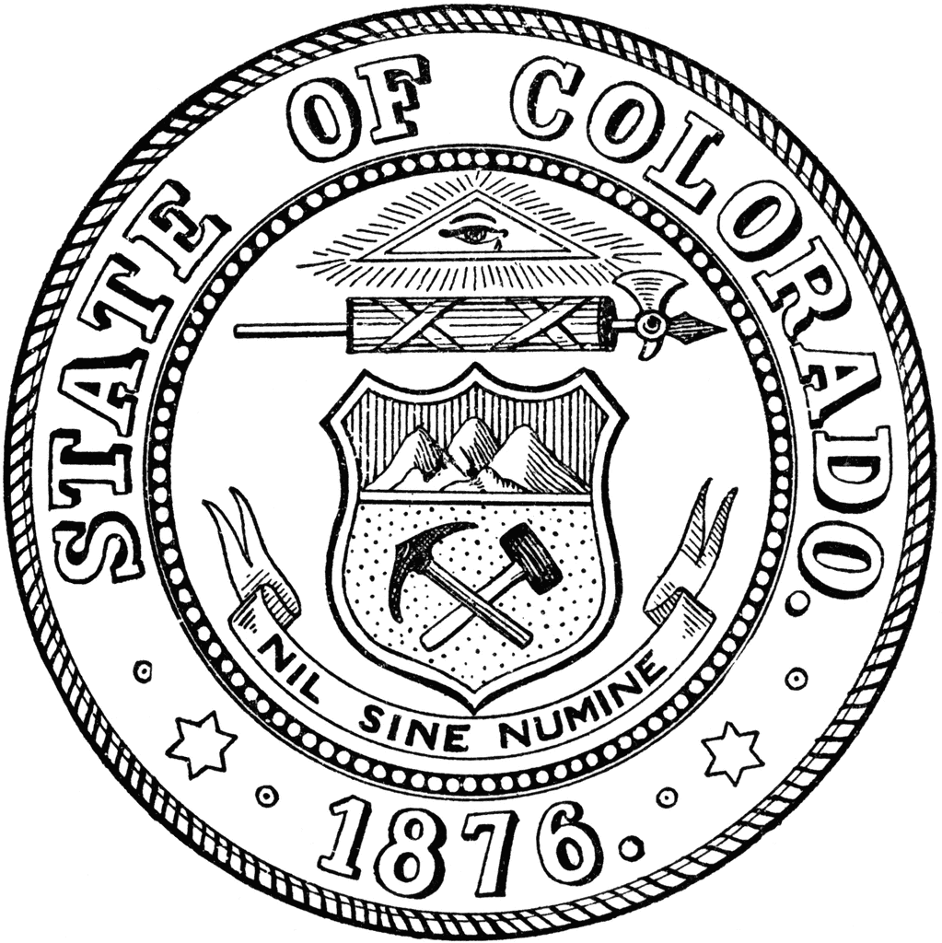
September 16, 2025
TEAMS
1:00 pm-3:00 pm

- Administration
  - Approval of August meeting minutes

- Introduction of new CTB Coordinator

- FY2026 Monthly Budget Update

- Denver County Agency Request History

- Local Board FY27 Project Awards – Discussion and Votes

- FY2027 Annual Agency -Discussion and Votes

- Updates from Board Members or visitors

- October Meeting Agenda Requests

Next Meetings:
Tuesday, October 21, 2025; 1 pm-3 pm
Tuesday, November 18, 2025; 1pm-3pm
Tuesday, December 16, 2025; 1pm-3pm

Meeting dates, minutes, and other documents are posted on the Correctional Treatment Board’s website: https://www.courts.state.co.us/Administration/Unit.cfm?Unit=ctb.

Board Co-Chair
Jaime FitzSimons, Sheriff
Summit County Sheriff’s Office

Board Co-Chair
Heather Salazar, Associate Director
Division of Adult Parole,
Department of Corrections

Board Members
James Karbach, State Public Defender
State Public Defender’s Office

Matthew Lunn, Director
Division of Criminal Justice
Department of Public Safety

Anjali Nandi, Director
Division of Probation Services
State Court Administrator’s Office

Danielle Culp, Director
Criminal Justice Services
Division of Community Behavioral Health
Behavioral Health Administration

Jessica Waggoner, District Attorney
Colorado District Attorney’s Council

________

Board Coordinator
Vacant
State Court Administrator’s Office
Division of Probation Services

