Correctional Treatment Board

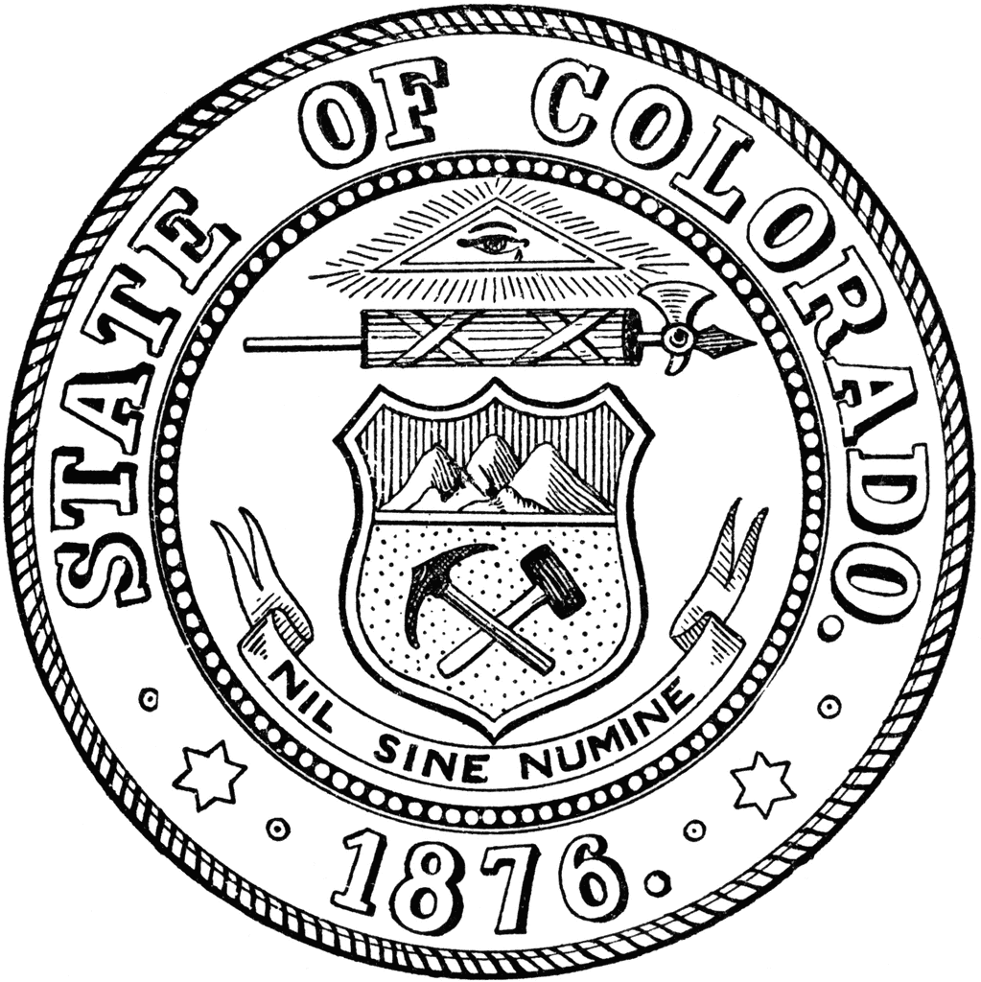
June 17, 2025
TEAMS
1:00 pm-3:00 pm

- Administration
  - Approval of meeting minutes

- FY2025 Monthly Budget Update
- FY2027 Budget Projections

- Local Board
- Grant Applications FY2027 closed June 1st
- Board members have access to start reviewing the Local Board grants for FY2027
- Amplifund Access Demonstration

- FY2027 Annual Agency Requests DUE August 1st, 2025

- Updates from Board Members or visitors

- July Meeting Agenda Requests
- Reminder: July’s meeting is all-day application interviews

Next Meetings:
Tuesday, July 15, 2024: All-Day Local Board Grant Interviews
Location: Ralph Carr Justice Center
2nd Floor, Headwaters Conference Room
Tuesday, August 19, 2025: 1 pm-3 pm
Tuesday, September 16, 2025: 1 pm-3 pm

Meeting dates, minutes, and other documents are posted on the Correctional Treatment Board’s website: https://www.courts.state.co.us/Administration/Unit.cfm?Unit=ctb.

Board Co-Chair
Jaime FitzSimons, Sheriff
Summit County Sheriff’s Office

Board Co-Chair
Heather Salazar, Associate Director
Division of Adult Parole,
Department of Corrections

Board Members
James Karbach, State Public Defender
State Public Defender’s Office

Matthew Lunn, Director
Division of Criminal Justice
Department of Public Safety

Anjali Nandi, Director
Division of Probation Services
State Court Administrator’s Office

Danielle Culp, Director
Criminal Justice Services
Division of Community Behavioral Health
Behavioral Health Administration

Jessica Waggoner, District Attorney
Colorado District Attorney’s Council

________

Board Coordinator
Frances Blair
State Court Administrator’s Office
Division of Probation Services

