|  |  |
| --- | --- |
| **Colorado Independent Judicial Discipline Adjudicative Board**  2 East 14th Avenue  Denver, CO 80203  Phone Number: 720-625-5150 | ▲ COURT USE ONLY *▲* |
| **Original Proceeding Pursuant to Colorado Constitution Article VI, § 23** |
| IN RE THE MATTER OF THE PEOPLE OF THE STATE OF COLORADO,  Complainant,  and  JUSTIN B. HAENLEIN, a District Court Judge of the 13th Judicial District,  Respondent. |
|  | CCJD Case Number: 24-176 |
| **ORDER VACATING STATUS CONFERENCE** | |

This matter comes before the Adjudicative Judicial Discipline Panel (“the Panel”) on Respondent Judge’s motion to vacate the Status Conference currently scheduled for May 8, 2025.

The Panel grants the request to vacate the Status Conference. Further orders from the Panel regarding the proposed stipulation will issue in due course.

Dated: May 7, 2025.

________________________

Tyrone Glover

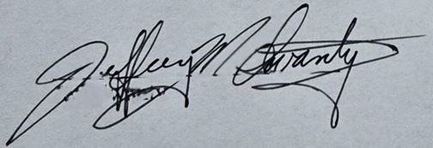

________________________

Jeff Swanty

________________________

Vincente Vigil