Correctional Treatment Board

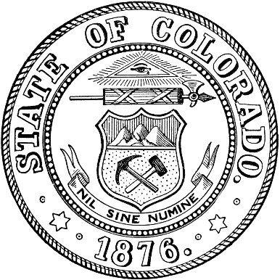
March 17, 2026
TEAMS
1:00 pm-3:00 pm

- Administration
  - Approval of February meeting minutes

- FY2026 Monthly Budget Update – Liz Hills

- FY2028 Messaging to Local Boards

- March 19th, Local Board Applications Open

- Update on Euna (previously called Amplifund)

- FY2027 Local Project Data

- Save the Date: July 21 and July 22nd Application Interviews at Ralph Carr

- Updates from Board Members or visitors

- April Meeting Agenda Requests

Next Meetings:
Tuesday, April 21, 2026, 1pm – 3pm
Tuesday, May 19, 2026, 1pm-3pm
Tuesday, June 16, 2026, 1pm-3pm

Meeting dates, minutes, and other documents are posted on the Correctional Treatment Board’s website: https://www.courts.state.co.us/Administration/Unit.cfm?Unit=ctb.

Board Co-Chair
Jaime FitzSimons, Sheriff
Summit County Sheriff’s Office

Board Co-Chair
Heather Salazar, Associate Director
Division of Adult Parole,
Department of Corrections

Board Members
James Karbach, State Public Defender
State Public Defender’s Office

Matthew Lunn, Director
Division of Criminal Justice
Department of Public Safety

Anjali Nandi, Director
Division of Probation Services
State Court Administrator’s Office

Danielle Culp, Director
Criminal Justice Services
Division of Community Behavioral Health
Behavioral Health Administration

Jessica Waggoner, District Attorney
Colorado District Attorney’s Council

________

Board Coordinator
Katy Post
State Court Administrator’s Office
Division of Probation Services

