# Correctional Treatment Board

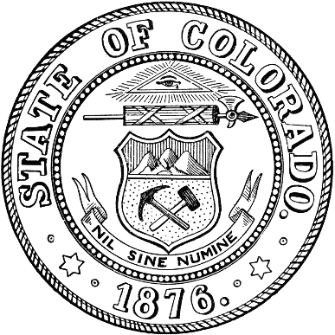

**July 15, 2025**

**In Person at Ralph Carr Justice Center**

**8:30 am- 4:30pm**

Attendance: Heather Salazar, Jaime FitzSimons, Anjali Nandi, Matt Lunn, James Karbach , Danielle Culp, Jessica Waggoner, Kelly Sawka

1. Administration
   * Approval of June meeting minutes
   * Discussed budget and plan for award interviews
2. A posting for the new CTB Coordinator will be coming soon. Once it is posted, it will be shared with the board.
3. Local Board FY27 Project Awards interview. The board interviewed 32 applicants today. They were told they will hear the outcomes sometime in September.
4. FY2027 Annual Agency Requests due August 1. Board extended start time to accommodate the need for further discussion on awards and hear the agency requests.
5. No Updates from Board Members or visitors

Next Meetings:

Tuesday, August 15, 2025; 12pm-4pm

September 16, 2025; 1pm-3pm

Tuesday, October 21, 2025; 1 pm-3 pm

Meeting dates, minutes, and other documents are posted on the Correctional Treatment Board’s website: <https://www.courts.state.co.us/Administration/Unit.cfm?Unit=ctb>.

## Board Co-Chair

Jaime FitzSimons, Sheriff

*Summit County Sheriff’s Office*

## Board Co-Chair

Heather Salazar, Associate Director

*Division of Adult Parole,*

*Department of Corrections*

## Board Members

James Karbach, State Public Defender

*State Public Defender’s Office*

Matthew Lunn, Director

*Division of Criminal Justice*

*Department of Public Safety*

Anjali Nandi, Director

*Division of Probation Services*

*State Court Administrator’s Office*

Danielle Culp, Director

*Criminal Justice Services*

*Division of Community Behavioral Health*

*Behavioral Health Administration*

Jessica Waggoner, District Attorney

*Colorado District Attorney’s Council*

________

## Board Coordinator

Vacant

*State Court Administrator’s Office*

*Division of Probation Services*