Correctional Treatment Board

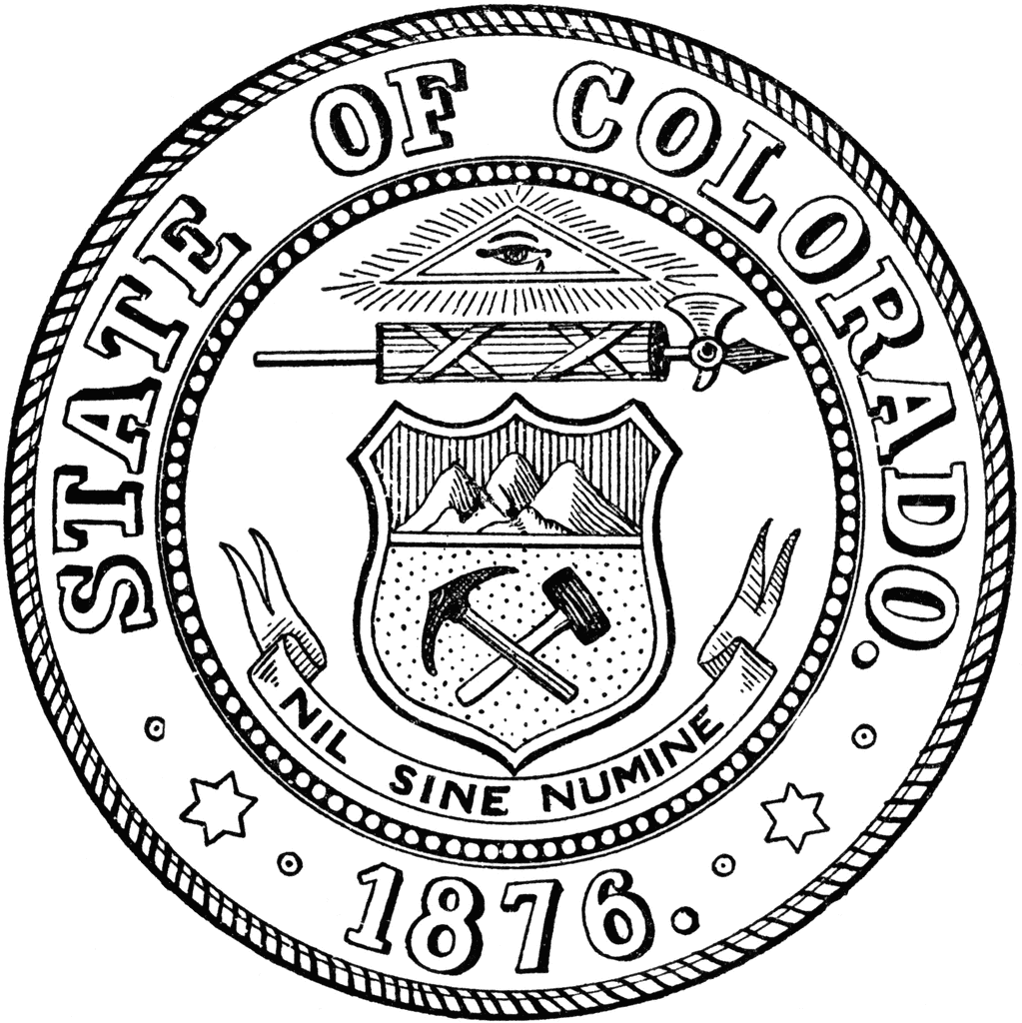
June 17, 2025

Present – James Karbach, Heather Salazar, Jaime Fitzsimons, Anjali Nandi, Matt Lunn, Danielle Culp

Absent : Jessica Waggoner
Guest – Carla Hanson filling in for the Correctional Treatment Board Coordinator, Ryan Ziehr, Amplifund Demonstrator

- Approved minutes for May 2025 Meeting

- Kelly Sawka reviewed the CTB monthly Budget including FY25 Budget Update, FY27 Projections, and expenditures as of June 2, 2025.

- Discussed Local Project Applications and July 15th Interview. Board was provided 3 options for a schedule and choose an option. Board discussed the need to keep interviews to 5 minutes. Ryan Ziehr provided an Amplifund Demonstration so the Board can review all applications prior to the interviews. Board requested that applicants be prepared for questions from the board and have one to two minute presentation available.

- The board was reminded that FY27 Agency Requests are due August 1, 2025.

Next Meetings:
Tuesday, July 15, 2024: All-Day Local Board Grant Interviews
Tuesday, August 19, 2025: 1 pm-3 pm
Tuesday, September 16, 2025: 1 pm-3 pm

Meeting dates, minutes, and other documents are posted on the Correctional Treatment Board’s website: https://www.courts.state.co.us/Administration/Unit.cfm?Unit=ctb.

Board Co-Chair
Jaime FitzSimons, Sheriff
Summit County Sheriff’s Office

Board Co-Chair
Heather Salazar, Associate Director
Division of Adult Parole,
Department of Corrections

Board Members
James Karbach, State Public Defender
State Public Defender’s Office

Matthew Lunn, Director
Division of Criminal Justice
Department of Public Safety

Anjali Nandi, Director
Division of Probation Services
State Court Administrator’s Office

Danielle Culp, Director
Criminal Justice Services
Division of Community Behavioral Health
Behavioral Health Administration

Jessica Waggoner, District Attorney
Colorado District Attorney’s Council

________

Board Coordinator
Frances Blair
State Court Administrator’s Office
Division of Probation Services

