Correctional Treatment Board

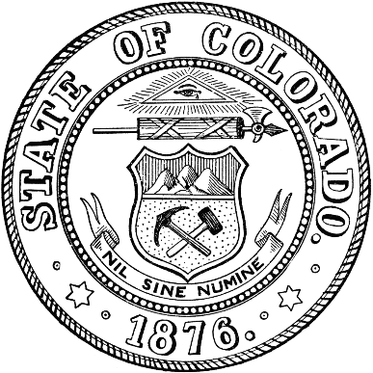
MINUTES
March 18, 2025

Members in Attendance: Heather Salazar, Dana Wilks, Danielle Culp, Jaime FitzSimons, Jessica Waggoner.

Guests in Attendance: Kelly Sawka, Robin Smart, and Katie Ruske for Matt Lunn.
Laura Brown and Molly Gamez from Denver Sherrif’s Department.

Administration
- Approved minutes for the October 2024 Meeting

Budget
- Reviewed FY2025 monthly spreadsheet
- Robin Smart did a general overview of the general budget climate

CCJC on track with planning and budget.

Project funding concerns reviewed.

Next Meetings:
Tuesday, April 15, 2025: 1pm-3pm
Tuesday, May 20, 2025: 1pm-3pm
Tuesday, June 17, 2025: 1pm-3pm

Meeting dates, minutes, and other documents are posted on the Correctional Treatment Board’s website: https://www.coloradojudicial.gov/probation/correctional-treatment-board?topic=155&wrapped=true

Board Co-Chair
Jaime FitzSimons, Sheriff
Summit County Sheriff’s Office

Board Co-Chair
Heather Salazar, Associate Director
Division of Adult Parole,
Department of Corrections

Board Members
James Karbach, State Public Defender
State Public Defender’s Office

Matthew Lunn, Director
Division of Criminal Justice
Department of Public Safety

Dana Wilks, Director
Division of Probation Services
State Court Administrator’s Office

Danielle Culp, Director
Criminal Justice Services
Division of Community Behavioral Health
Behavioral Health Administration

Jessica Waggoner, District Attorney
Colorado District Attorney’s Council

________

Board Coordinator
Frances Blair
State Court Administrator’s Office
Division of Probation Services

